By setting H as a constant, one can get two S* from different strains; similarly, by setting S as a constant, one can get two H* from different strains.
When $S_{1}^{*}=S_{1}^{*}$ or $H_{1}^{*}=H_{2}^{*}$ the system might be coexistence.

When systems cannot coexist, the equilibrium is unstable.
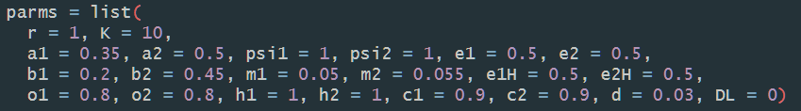
Set H as constant:
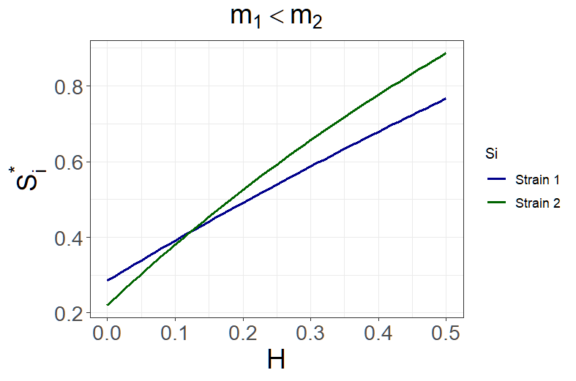

Set H as constant
